

|  |
| --- |
| **COURSEWORK ASSESSMENT SPECIFICATION** |

|  |  |
| --- | --- |
| **Module Title:** | *Programming 2* |
| **Module Number:** | *KV4001* |
| **Module Tutor Name(s):** | *Alan Maughan* |
| **Academic Year:** | *2018/19* |
| **% Weighting (to overall module):** | *7.5%* |
| **Coursework Title:** | *Homework 1* |
| **Average Study Time Required by Student:** | *8 hours* |

**Dates and Mechanisms for Assessment Submission and Feedback**

|  |
| --- |
| **Date of Handout to Students:**  Week 2 |
| **Mechanism for Handout to Students:**  *via Blackboard* |
| **Date and Time of Submission by Student:**  During Week 3 Lab Class |
| **Mechanism for Submission of Work by Student:**  Papers collected in lab |
| **Date by which Work, Feedback and Marks will be returned to Students:**  Marks & feedback will be given as the assessment is marked in the lab week 3. |
| **Mechanism for return of assignment work, feedback and marks to students:**  Marks & feedback will be given as the assessment is marked in the lab |

**Further Information**

*(Please ensure the assessment specification includes the following items)*

**Learning Outcomes tested in this assessment (from the Module Descriptor):**

3. Create a set of test cases using appropriate black and white box analysis.

**Nature of the submission required:**

Paper copies of source code & simple test plan. Code execution in lab.

**Instructions to students:**

*This is an individual piece of work.*

**Referencing Style:**

*N/A*

**Expected size of the submission**:

2 pages – a set of truth tables & a set of test cases.

**Academic Conduct:**

You must adhere to the university regulations on academic conduct. Formal inquiry proceedings will be instigated if there is any suspicion of misconduct or plagiarism in your work. Refer to the University’s regulations on assessment if you are unclear as to the meaning of these terms. The latest copy is available on the university website.

# Homework 1

### Due in your lab in week 3

## Task Specification

Attached to this specification is a copy of the code for a Java method. Your task is to design test cases to exercise the method using the Multiple Condition Coverage criteria.

You must produce the following documentation which should contain your name and student id:

* The set of truth tables arising out of your analysis of the code;
* A completed Test Plan.

### The documentation must be word-processed. This is to ensure that you have attempted the work prior to the laboratory session. *Any hand written material will be ignored.*

## Marking

The work is worth 3 marks.

The homework will be marked at the start of your laboratory session. At that session your laboratory tutor will:

1. Check your documentation. If you do not have both sets of documentation you will receive 0 marks. The documentation will not be marked but is a prerequisite for receiving any mark.
2. Run a program into which you will enter your test cases, as per the test plan. Only test data listed on the test plan may be used. Any entries hand written will be not be used. The program will assign you a mark.

The marks for the homework are based on your test cases satisfying the MCC criteria. In order to obtain 3 marks your test cases must have fully satisfied the MCC criteria. Anything less and you will receive either 0, 1 or 2 marks. You may have some test data but unless you trigger a certain threshold you will not gain any marks.

***Note: You will only be allowed one attempt at gaining the homework marks.***

## Supporting Material

A version of the program is available on the module Blackboard site. This program has a GUI front end. You should use the program to check out your test cases.

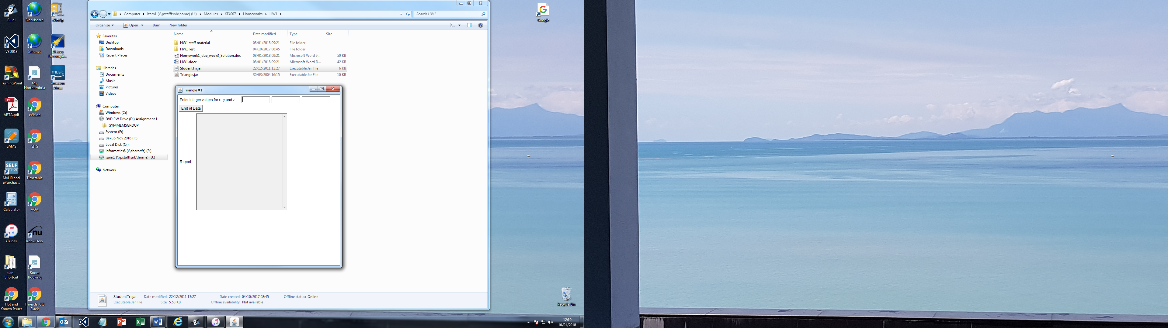

You should:

* Enter the first set of test data;
* Hit enter to load the test
* Put the cursor in the first text box ready for the next test;
* Repeat as long as you have further test data.
* On completion click ‘End of Data’ to get the test results.

Remember you are designing test cases to exercise the accompanying method. You are NOT testing the GUI.

## The Method to test:

public String checkValues(int i, int j, int k)

{

int match;

if (!( (i>0) && (j>0) && (k>0) ))

{

return "\nInvalid sides for triangle \n";

}

else if ((i>=j+k) || (j>=k+i) || (k>=i+j))

{

return "\nNot a triangle\n";

}

else

{

match = 0;

if (i==j)

{

match = match + 1;

}

if (j==k)

{

match = match + 1;

}

if (k==i)

{

match = match + 1;

}

if (match == 0)

{

return "\nScalene triangle\n";

}

else

{

if (match == 1)

{

return "\nIsoceles triangle\n";

}

else

{

return "\nequilateral triangle\n";

}

}

}

}